MongoDB Assignment 2
- Create a database named university and a collection named students. Insert multiple student documents with fields: name, age, department, and grades.

Creating database and collection
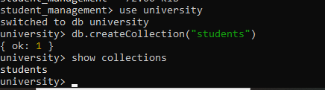

Data insertion
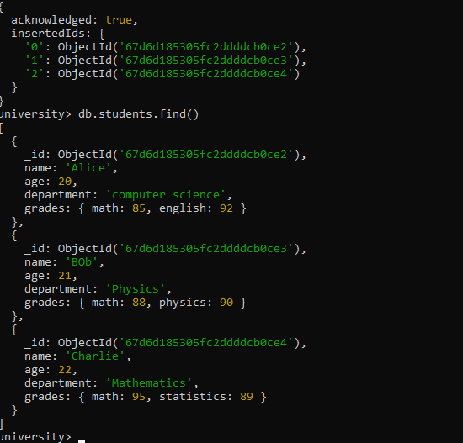

- Write a query to display all students who are in the Computer Science department.

db.students.find({department:"computer science"})

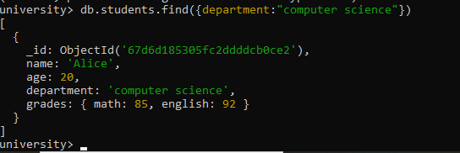

- Write a query to update the grades of a student named Alice by adding a new subject programming with a grade of 93.
db.students.updateOne(
{ name: "Alice" },
{ $set: { "grades.Programming": 93 } }
);
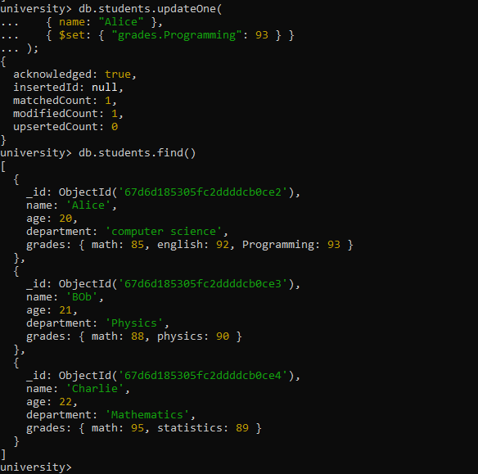

- Write a query to increment the age of all students by 1.
db.students.updateMany({},{$inc:{age:1}})

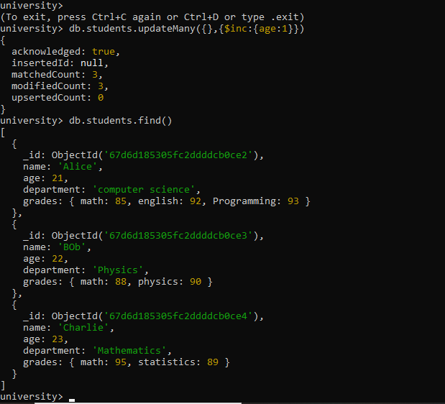
- Write a query to delete all students who are 23 years old.
db.students.deleteMany({age:23})

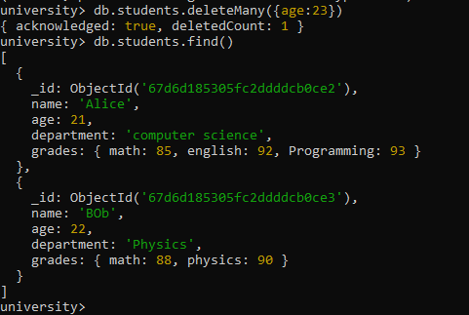
- Write a query to create an index on the name field of the students collection.

db.students.createIndex({ name: 1 });

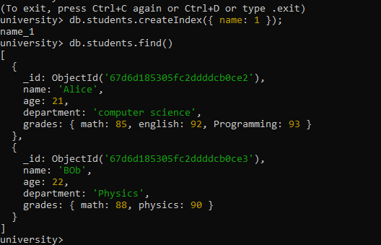

- Write an aggregation query to group students by their department and calculate the average age in each department.

db.students.aggregate([
{
$group: {
_id: "$department",
averageAge: { $avg: "$age" }
}}]);
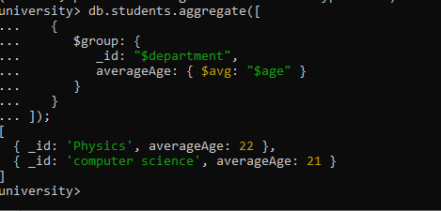

- Write a query to find all students who have scored more than 90 in any subject.

db.students.find({
$expr: {
$gt: [
{ $max: { $objectToArray: "$grades" } },
90
]
}
});

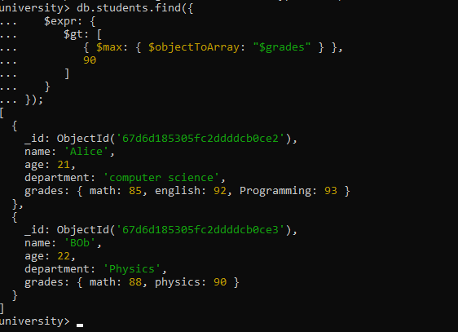

- Write a query to add a new field graduated set to false for all students who are in the Mathematics department.

db.students.updateMany(
{ department: "math" },
{ $set: { graduated: false } }
);

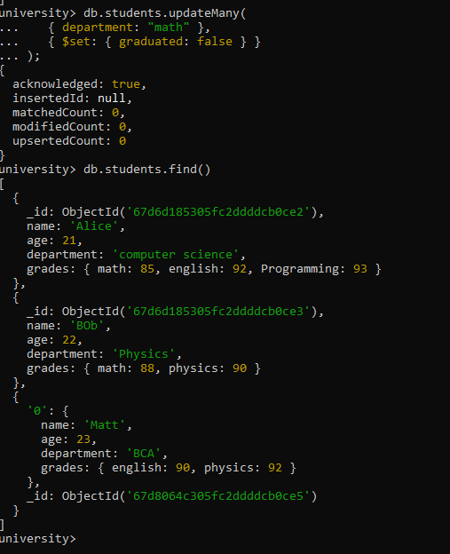

db.students.updateMany(
{ department: "Mathematics" },
{ $set: { graduated: false } }
);

- How can you retrieve only the name and department fields for all students, excluding the _id field?
db.students.find(
{},
{ name: 1, department: 1, _id: 0 });

